**A**

**Summer Internship Report**

**On**

**“WEB DEVELOPMENT”**

(IT346 – Summer Internship - I)

**Prepared by**

ISHA PATEL(20IT095)

**Under the Supervision of**

Dr./Prof. NITA JADAV

**Submitted to**

Charotar University of Science & Technology (CHARUSAT)

for the Partial Fulfillment of the Requirements for the

Degree of Bachelor of Technology (B.Tech.)

for Semester 5

**Submitted at**



**Accredited with Grade A by NAAC**

**Accredited with Grade A by KCG**



**SMT. KUNDANBEN DINSHA PATEL DEPARTMENT OF INFORMATION TECHNOLOGY**

**Chandubhai S. Patel Institute of Technology (CSPIT)**

**Faculty of Technology & Engineering (FTE), CHARUSAT**

**At: Changa, Dist: Anand, Pin: 388421.**

**July, 2022**



**Accredited with Grade A by NAAC**

**Accredited with Grade A by KCG**

This is to certify that the report entitled “Web Development” is a bonafied work carried out by ISHA PATEL(20IT095) under the guidance and supervision of Prof. Nita Jadav & Mr. Bhavik Patel for the subject Summer Internship – I (IT346) of 5th Semester of Bachelor of Technology in Department of Information at Chandubhai S. Patel Institute of Technology (CSPIT), Faculty of Technology & Engineering (FTE) – CHARUSAT, Gujarat.

To the best of my knowledge and belief, this work embodies the work of candidate herself, has duly been completed, and fulfills the requirement of the ordinance relating to the B.Tech. Degree of the University and is up to the standard in respect of content, presentation and language for being referred by the examiner(s).

|  |  |
| --- | --- |
| Under the supervision of,  Prof. Nita Jadav  Smt. Kundanben Dinsha Patel Department of Information Technology  CSPIT, FTE, CHARUSAT, Changa, Gujarat | Mr. Bhavik Patel  Magic Technolab Pvt Ltd |
| Dr. (Prof.) Parth Shah  Head of Department (IT)  CHARUSAT, Changa, Gujarat. | |

**Chandubhai S. Patel Institute of Technology (CSPIT)**

**Faculty of Technology & Engineering (FTE), CHARUSAT**

At: Changa, Ta. Petlad, Dist. Anand, Pin: 388421. Gujarat.

**COMPANY CETIFICATE**



**Acknowledgement**

With great pleasure, I would like to extend my sincere gratitude and thanks to my parents for their sincere support they have given me.

I would like to also thank Mr. Bhavik Patel , Magic Technolab Pvt Ltd for the care and support they gave me all thought my internship and also giving me a chance to spend my practice in his company and helping me in my day to day activities during the intern time.

I perceive as this opportunity as a big milestone in my career development. I will strive to use gained skills and knowledge in the best possible way, and I will continue to work on their improvement, in order to attain desired career objectives. Hope to continue cooperation with all of you in the future.

Thank You,  
Sincerely,

Isha Patel

**ABSTRACT**

I have carried out my internship based on programming with web development. I have learn to use live server on the browser.

I have prepare the min Project which an E-commerce website for online pharmacy shopping.

I have implemented this with frontend and backend and on server side.

**Description of company**

Company Consistently Working On Asterisk, Freeswitch, Opensips, And Kamailio .There Are End Numbers Of Projects Completed With Complete Results Within A Timeline. After Completed 300+ Projects On VoIP Development, We Had Started Working On Web And App Developments And Technologies Are Core PHP, CMS, Mobile Apps, ERP & CRM

Number of employees

The number of employees are 15.

Location and spread of company

403 Landmark, 100 Feet Anand Nagar Rd, opp. Seema Hall, Prahlad Nagar, Ahmedabad, Gujarat 380015

Branches: 0

**Table of Contents**

Acknowledgement 5

Abstract 6

Description of company / organization………………………………………………………………………7

**Chapter 1 Introduction 8**

1.1 Project OverView 9

1.2 Objective 9

**Chapter 2 Tools and Technology 10**

2.1 Tools 11

2.1.1 Visual Studio Code 11

2.1.2 phpmyadmin 11

2.1.3 XAMPP 12

2.2 Technology 13

2.1.1 HTML AND CSS 13

2.1.2 BOOTSTRAP 14

2.1.3 PHP 14

2.1.3 MySQL 15

2.3.HARDWARE REQUIREMENT 16

2.2 SOFTWARE REQUIREMENT 16

**Chapter 3 PROJECT MANAGEMENT 17**

3.1 Planning of project 18

**Chapter 4 IMPLEMENTATION 19**

3.1 Implementation Background 20

3.2 Implementation Screenshots 20

**Chapter 5 Conclusion 21**

**References 22**

**List of Figures**

**Fig 2.1 Visual Studio Code 12**

**Fig 2.2 phpMyAdmin 13**

**Fig 2.3 XAMPP 13**

**Fig 2.4 HTML AND CSS 14**

**Fig 2.5 Bootstrap 15**

**Fig 2.6 PHP 16**

**Fig 2.7 MySQL 16**

**Fig 3.1 PROJECT PLANNING 19**

**Fig 4.1 Main Page 21**

**Fig 4.2 User login 22**

**Fig 4.3 User sign up 22**

**Fig 4.4 Search 23**

**Fig 4.5 Product 23**

**Fig 4.6 Shopping cart 24**

**Fig 4.7 Admin home 24**

**CHAPTER:-1**

**INTRODUCTION**

* 1. **PROJECT OVERVIEW:**

Our assignment E-pharmacy operates over the  
net through promoting prescribed drugs or medicinal drugs online  
and sends orders to clients via the mail or other method.  
one of the technological advances that is set to create a  
good sized call for within the next days is on line pharmacy.  
when clients have a favorable opinion regarding on-line  
purchasing, it does not usually transfer into everyday buy  
hobby. The purpose of this examine is to inspect the connection  
among customer perceptions of values and dangers, as properly  
as online buying attitudes and behavior, inside the context of  
online pharmacy shopping. the ease of buying  
drugs on line has made it pretty popular all around the  
global. companies promote everything from prescriptions to different  
healthcare resources on their websites. The Indian healthcare  
marketplace is expanding unexpectedly, and both on line and offline  
pharmacies are actually working similarly.

* 1. **OBJECTIVE**

The main objective to make this project of web based application is to the learn and implement the basic to advanced knowledge concepts of HTML, CSS, Bootstrap, PHP and MySQL that have been known to us or have been learned by us. Further another goal apart from the learning that has been setup by us at the online pharmacy shopping is to help all the necessary people out there with all the knowledge that we have learned.

**CHAPTER-2**

**TOOLS AND TECHNOLOGIES**

**2.1 TOOLS**

# **2.1.1. Visual Studio Code**

Visual Studio Code, also commonly referred to as VS Code, is a [source-code editor](https://en.wikipedia.org/wiki/Source-code_editor) made by [Microsoft](https://en.wikipedia.org/wiki/Microsoft) for [Windows](https://en.wikipedia.org/wiki/Windows), [Linux](https://en.wikipedia.org/wiki/Linux) and [macOS](https://en.wikipedia.org/wiki/MacOS). Features include support for [debugging](https://en.wikipedia.org/wiki/Debugging), [syntax highlighting](https://en.wikipedia.org/wiki/Syntax_highlighting), [intelligent code completion](https://en.wikipedia.org/wiki/Intelligent_code_completion), [snippets](https://en.wikipedia.org/wiki/Snippet_(programming)), [code refactoring](https://en.wikipedia.org/wiki/Code_refactoring), and embedded [Git](https://en.wikipedia.org/wiki/Git). Users can change the [theme](https://en.wikipedia.org/wiki/Theme_(computing)), [keyboard shortcuts](https://en.wikipedia.org/wiki/Keyboard_shortcut), preferences, and install [extensions](https://en.wikipedia.org/wiki/Plug-in_(computing)) that add additional functionality.



Figure 2.1. Visual Studio Code

# **2.1.2. phpmyadmin**

phpMyAdmin is one of the most popular applications for MySQL database management. It is a free tool written in PHP. Through this software, you can create, alter, drop, delete, import and export MySQL database tables. You can run MySQL queries, optimize, repair and check tables, change collation and execute other database management commands.



Figure 2.2 phpMyAdmin

# **2.1.3. XAMPP**

XAMPP is one of the widely used cross-platform web servers, which helps developers to create and test their programs on a local webserver. It was developed by the Apache Friends, and its native source code can be revised or modified by the audience. It consists of Apache HTTP Server, MariaDB, and interpreter for the different programming languages like PHP and Perl. It is available in 11 languages and supported by different platforms such as the IA-32 package of Windows & x64 package of macOS and Linux.



Figure 2.3 XAMPP

**2.2 TECHNOLOGY**

**2.2.1. HTML AND CSS**

Before I started the project, I had to consider accessibility issues and web standards. I have created a strict XHTML file that contains two sections, a list section for the flag button (<li>) and another section for the change button (<div>). A major concern for web accessibility is the use of images. For users who can't distinguish between images, we recommend adding the "alt" and "title" attributes. For example, the title of the image of the German flag is "Deutsch" and the alt attribute is set to "German flag". The lang attribute is also set to English (lang = ”en”), which tells the browser the default human language of the script. This is essential for proper reading of web pages by certain disabled technologies.  
The main style is stored in an external table, but an HTMLDOMstyle object was also used to change some settings while loading JavaScript. For example, in the Edit module's Save button, visibility 8 is set to Hide in the external stylesheet, but to avoid confusion, clicking the Edit button changes the property to Show. increase. Another method I used to change JS properties is the jQuery .css () method. Found to be effective in changing the background and border properties of an object.



Figure 2.4 HTML AND CSS

**2.2.2 Bootstrap**

Bootstrap is a free open source tool suite for building responsive websites and web applications. This is the most popular HTML, CSS, and JavaScript framework for developing responsive mobile-first websites. Today, this website is perfect for all browsers (IE, Firefox, and Chrome) and all screen sizes (desktop, tablet, phablet, and phone). Thanks to Bootstrap developers Mark Otto and Jacob Thornton on Twitter, who were later declared an open source project.  


Figure 2.5 Bootstrap

**2.2.3 PHP**

PHP Hypertext Preprocessor (PHP) is a programming language that allows web developers to create dynamic content that interacts with databases. PHP is primarily used to develop web-based software applications. This tutorial will help you build your base using PHP.  
PHP started out as a small open source project and evolved as more and more people discovered how useful it was. Rasmus Lerdorf released the first version of PHP in 1994.  


Figure 2.6 PHP

**2.2.4 MySQL**

The MySQL tutorials provide basic MySQL concepts and advanced MySQL concepts. Our MySQL tutorials are aimed at both beginners and professionals.  
MySQL is a relational database management system based on the structured query language, which is a common language for accessing and managing records in a database. MySQL is open source free software under the GNU license. Supported by Oracle Company.



Figure 2.7 MySQL

**2.3 HARDWARE REQUIREMENT**

* Intel i5 10th gen processor
* 10 GB RAM
* Operating System :- Windows 10

**2.4 SOFTWARE REQUIREMENT**

* Software :- Visual Studio Code,XAMPP,phpMyAdmin
* Front-end:- HTML , CSS
* Back-end:- PHP, MySQL

**CHAPTER-3**

**PROJECT MANAGEMENT**

**3.1. Project Planning:**

In any project, for a perfect execution what major requirement is the planning of the execution. Our project, just like the other project has to be properly planned beforehand too. To understand and manage our workflow after gathering the required knowledge about what to do, the first thing that we did was to refer the reports of the earlier projects to know about the planning and the way of execution. After going on through a lot of samples, and discussing in various group meets we finally decided to go with the following planning chart that was highly inspired by the some successful projects that were done and noticed by us earlier.

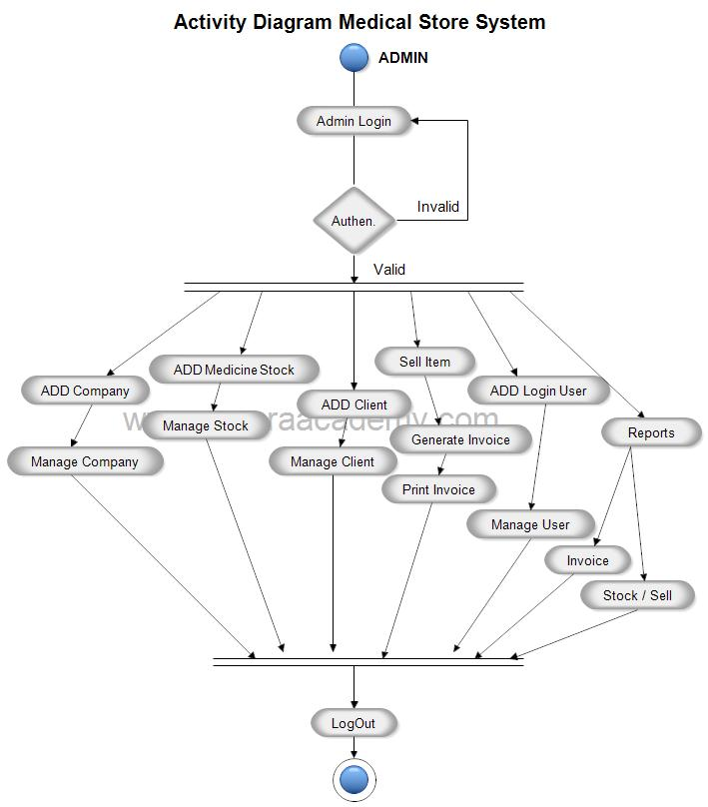

Figure 3.1 PROJECT PLANNING

**CHAPTER 4:IMPLEMENTATION**

**4.1 Implementation Background:**

The backbone and the main aspect from the software side of the project was to run the HTML code, php , and bootstrap. So the implementation was carried out in such a way that co-relation of different files would be done easily. Hence, the use of an IDE was a must. Sometimes to organize we even had to use some text editors like sublime text, atom etc. Implementation of the code was done all together after we researched and sorted the image data that we obtained. Basic approach that we used was the partial compilation method and went on integrating the small amount of the code to larger ones, module by module

**4.2 Implementation Screenshots:**

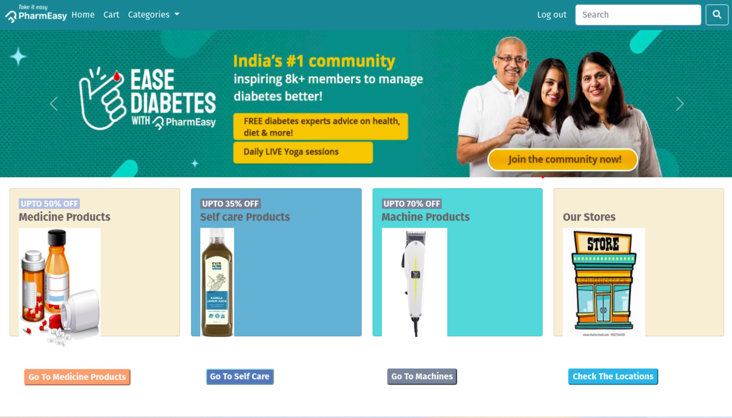

Figure 4.1 Main Page

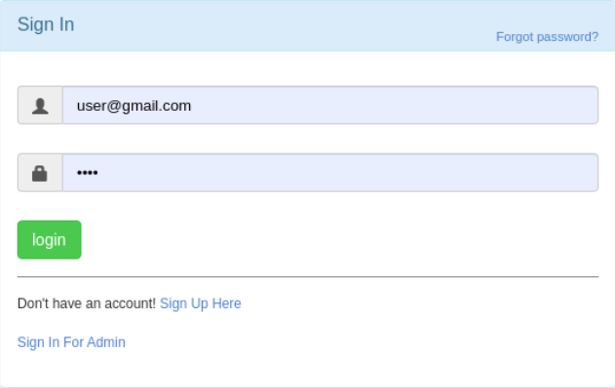

Figure 4.2 user login

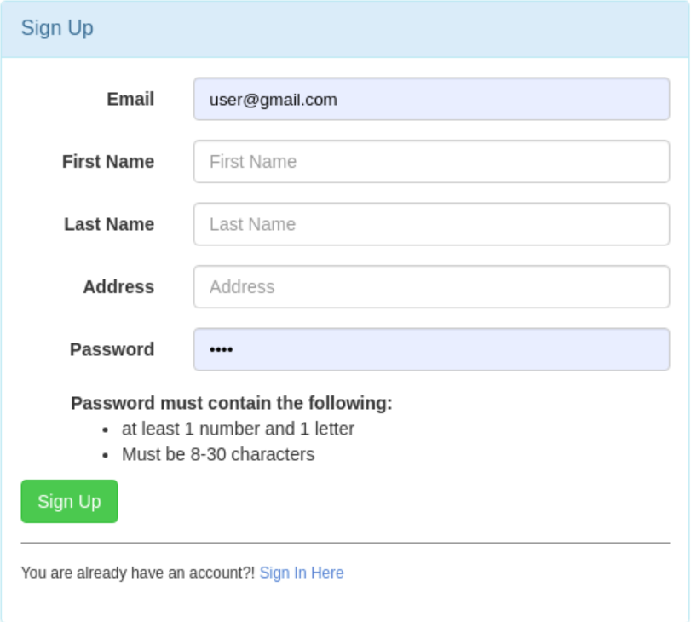

Figure 4.3 user sign up

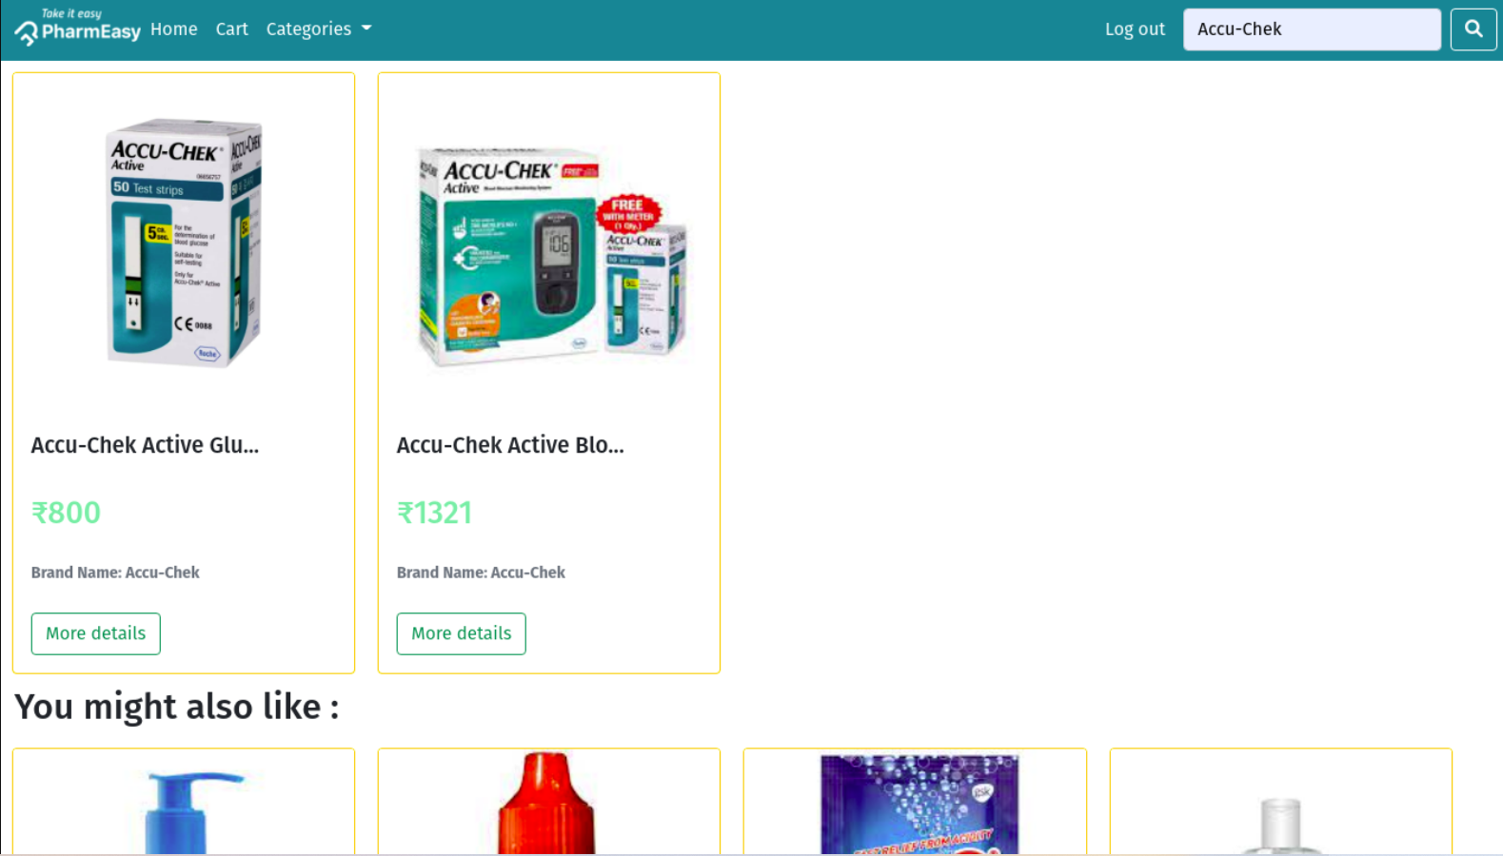

Figure 4.4 search

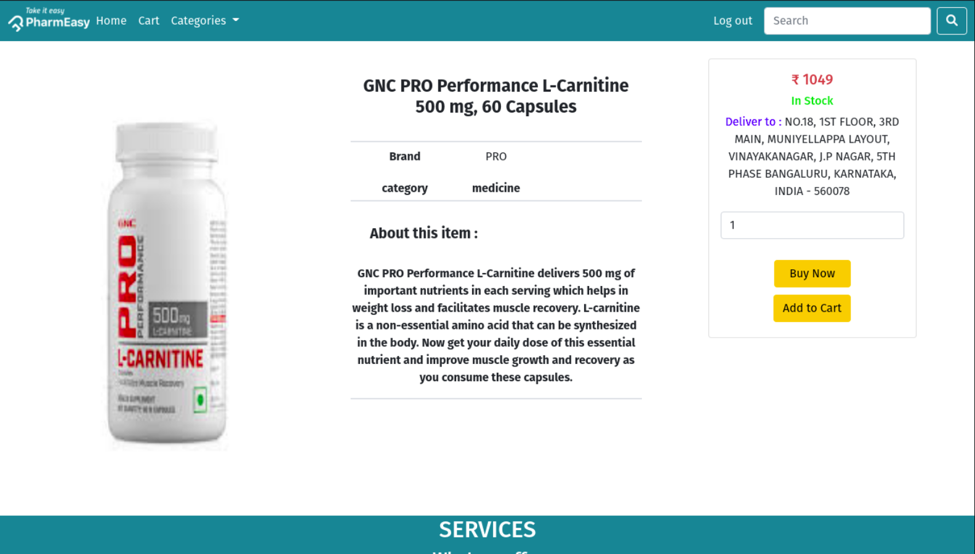

Figure 4.5 product

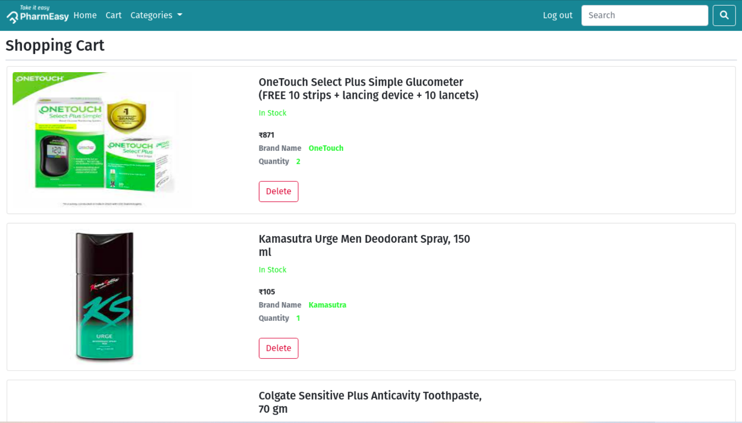

Figure 4.6 shopping cart

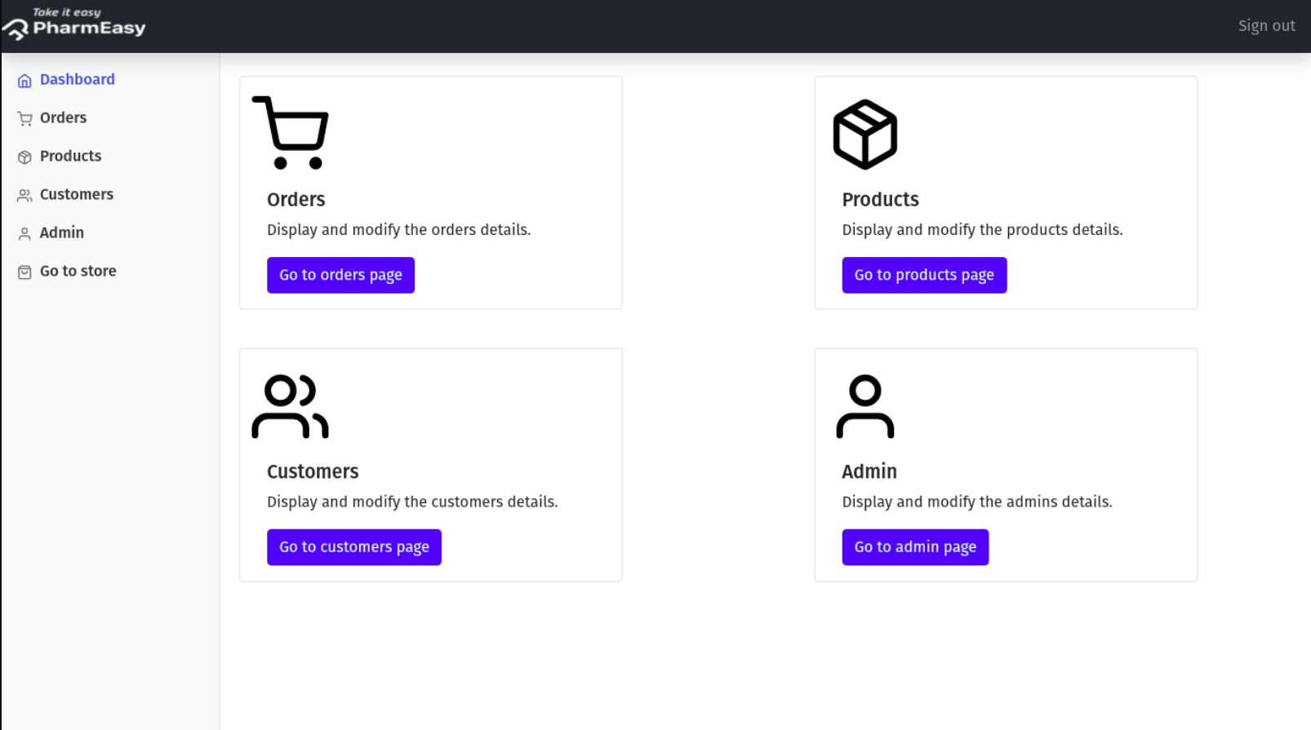

Figure 4.7 Admin home

**CHAPTER-5**

**CONCLUSION**

In this internship has been an excellent and rewarding experience. Ican conclude that there have been a lot I’ve learnt from my work at Magic Technolab Pvt Ltd. Needless to say, the technical aspects the work I’ve done are not flawless and could be improved provided enough time. As someone with no prior experience with PHP and MySQL. I believe my time spent in research and discovering it was well worth it and contributed to finding an acceptable solution to build a fully functional Web service. Two main things I’ve learned that importance of time-management andself-motivation.

**References**

1. <https://www.w3schools.com/php/>
2. <https://www.tutorialspoint.com/php/index.htm>
3. <https://getbootstrap.com/>
4. <https://www.geeksforgeeks.org/bootstrap/>